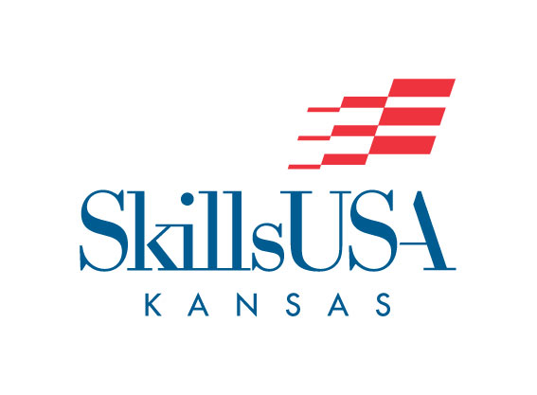

Special Needs Request Form

SkillsUSA Kansas will make every effort to assist/accommodate, as appropriate, to create equal opportunities and a level playing field for all contestants. No assistance will be provided that could be interpreted as giving the special needs contestant an unfair advantage.

Advance identification of the contestants and their special needs will be required. The following are examples of the types of assistance that are allowed:

- Special tables will be allowed for contestants who need to use wheelchairs.
- Signers will be allowed to translate oral instructions given by the technical committee to deaf or hearing-impaired contestants.
- Special tools and devices will be allowed for contestants with prosthetics or physical challenges such as a club foot, burn injury or amputation.
- Contestants with dyslexia or other learning disabilities will be allowed assistance as determined by the complexity of the contest assignment.
- Readers will not be allowed in contests where the use of technical manuals is required.

NAME OF SCHOOL:

NAME OF SCHOOL ADVISOR:

NAME OF CONTESTANT:

CONTEST IN WHICH THE CONTESTANT WILL BE COMPETING:

ASSISTANCE NEEDED:

If special equipment is required, will your school provide this? YES NO

Request Approved: _____________________________ Date: ______________
SkillsUSA State Director

Request must be submitted by March 1
Email to: bwarren@ksde.org

