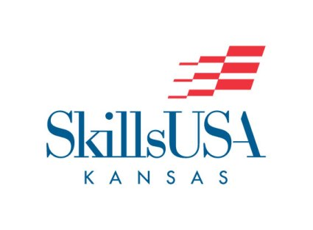

Become a Contest Judge
SkillsUSA Kansas utilizes our partners as contest chairs and judges for the State Leadership and Skills Conference. Business and Industry supply the Kansas organization with contest chairs, judges, and award prizes for the contest they are hosting. Many of our contests have multiple partnerships from business and industry pulling together for one contest area.
SkillsUSA Kansas business and industry are supporters of career and technical education. These businesses have an opportunity for input into skill training, a chance to recruit top technical students and the opportunity to help develop America’s future workforce.
SkillsUSA Kansas serves more than 1,500 career and technical competitors annually. These students are training in our State’s high schools and college/postsecondary institutions in a variety of careers such as cosmetology, automotive technology, machining, drafting, culinary arts and computer networking and much more.
More than 1,200 companies and organizations participate in SkillsUSA programs nationwide. Companies benefit by having input into specific skill training, an opportunity to recruiting top technical students, and the good feeling that comes from helping America’s future workforce develop marketable skills. Many industries today face a shortage of skilled workers, and SkillsUSA offers a tangible way to help solve this problem by ensuring that there will be a future workforce trained in the skills industry needs.
The SkillsUSA Kansas competitions consist of:
3-D Visualization & Animation
Action Skills
Additive Manufacturing Technology
Advertising Design
Architectural Drafting
Automated Manufacturing Technology
Automotive Maintenance & Light Repair
Automotive Refinishing Technology
Automotive Service Technology
Aviation Maintenance Technology
Cabinetmaking
Career Pathways Showcase: Arts & Communications
Career Pathways Showcase: Business, Management, Administration
Career Pathways Showcase: Human Services
Career Pathways Showcase: Health Sciences
Career Pathways Showcase: Industrial & Engineering Technology
Career Pathways Showcase: Natural Resources / Agriculture / Food
Carpentry
Chapter Business Procedure
Chapter Display
CNC Milling
CNC Technician
CNC Turning
Collision Damage Appraisal and Total Loss Evaluation Technology
Collision Repair Technology
Commercial Baking
Community Action Project
Community Service
Computer Programming
Cosmetology
Crime Scene Investigation
Criminal Justice
Criminal Justice Bowl
Culinary Arts
Customer Service
Cyber Security
Dental Assisting
Diesel Equipment Technology
Drone Technology
Electrical Construction Wiring
Engineering Technology Design
Entrepreneurship
Esthetics – Beauty Therapy
Extemporaneous Speaking
Firefighting
First Aid/CPR
Health Knowledge Bowl
Health Occupations Professional Portfolio
HVACR (Heating, Ventilation, Air Conditioning, Refrigeration)
Industrial Motor Control
Information Technology Systems
Interactive Application & Video Gaming
Internetworking
Job Interview
Job Skill Demonstration A
Job Skill Demonstration Open
Masonry
Mechatronics
Medical Math
Medical Terminology
Mobile Electronics Technology
Mobile Robotics Technology
Nail Care
Nurse Assisting
Opening and Closing Ceremony
Outstanding Chapter
Photography
Pin Design
Plumbing
Precision Machining Technology
Prepared Speech
Promotional Bulletin Board
Quiz Bowl
Related Technical Math
Restaurant Services
Robotics and Automation Technology
Robotics: Urban Search and Rescue
T-shirt Design
Team Engineering Challenge (Middle School contest)
Teamworks (Carpentry, Electrical, Masonry, Plumbing)
Technical Computer Applications
Technical Drafting
Television Video Production
Web Design
Welding
Welding Fabrication
Welding Sculpture

If you would like to become involved, please fill out the information below, marking the contest area above you are interested in serving. Once the director receives your information, she will share ways we can build a partnership to promote America’s emerging skilled workforce.
NAME:
COMPANY:
ADDRESS:
WORK PHONE:
CELL PHONE:
Thank you for volunteering to serve in supporting Career and Technical Education and the SkillsUSA Organization. We are truly grateful for your service. Please email this form to bwarren@ksde.org to be processed.
Sincerely,
Becky Warren
Director, SkillsUSA Kansas
Phone: 620-820-9367
Email: bwarren@ksde.org

